**ASSIGNMENT-03**

**Build CNN Model for Classification Of Flowers**

|  |  |
| --- | --- |
| **Assignment Date** | 5 October 2022 |
| **Student Name** | Miridini V |
| **Student Roll Number** | 113219071019 |
| **Maximum Marks** | 2 Marks |

QUESTION 1:

Download the Dataset

Dataset is downloaded and uploaded

QUESTION 2:

Image Augmentation

from tensorflow.keras.preprocessing.image import ImageDataGenerator

rose_datagen=ImageDataGenerator(rescale=1.255,horizontal_flip=True,vertical_flip=True)

x_data= rose_datagen.flow_from_directory(r"/content/drive/MyDrive/IBM Assignments/flowers",target_size=(64,64),class_mode="categorical",batch_size=24)

x_data.class_indices

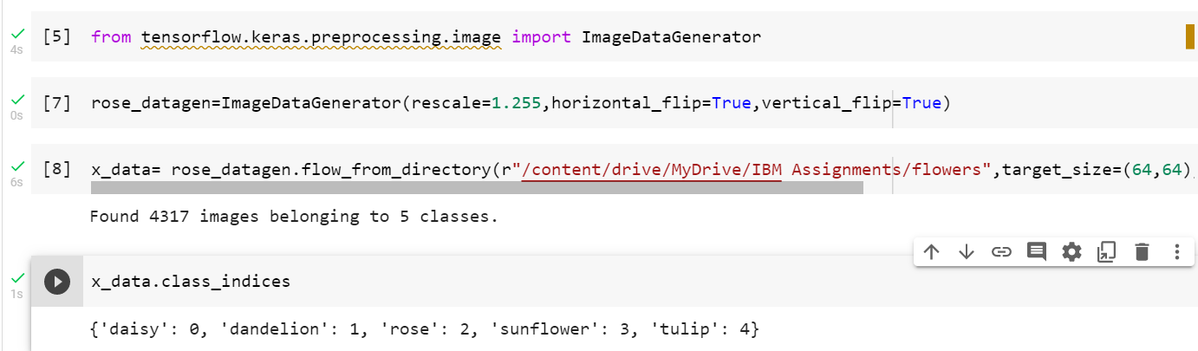

QUESTION 3:

Create Model

from tensorflow.keras.models import Sequential

from tensorflow.keras.layers import Dense,Convolution2D,MaxPooling2D,Flatten

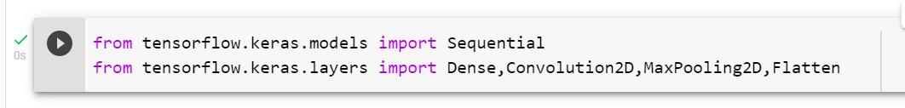

QUESTION 4:

Add Layers (Convolution,MaxPooling,Flatten,Dense-(Hidden Layers),Output

model.add(Convolution2D(34,(3,3),activation="relu",strides=(1,1),input_shape=(64,64,3)))

model.add(MaxPooling2D(pool_size=(2,2)))

model.add(Flatten())

model.summary()

model.add(Dense(200,activation="relu"))

model.add(Dense(200,activation="relu"))

model.add(Dense(5,activation="softmax"))

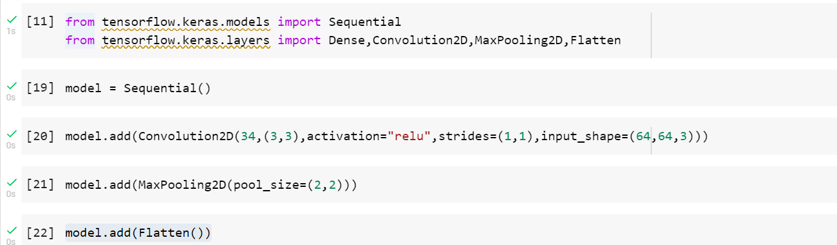

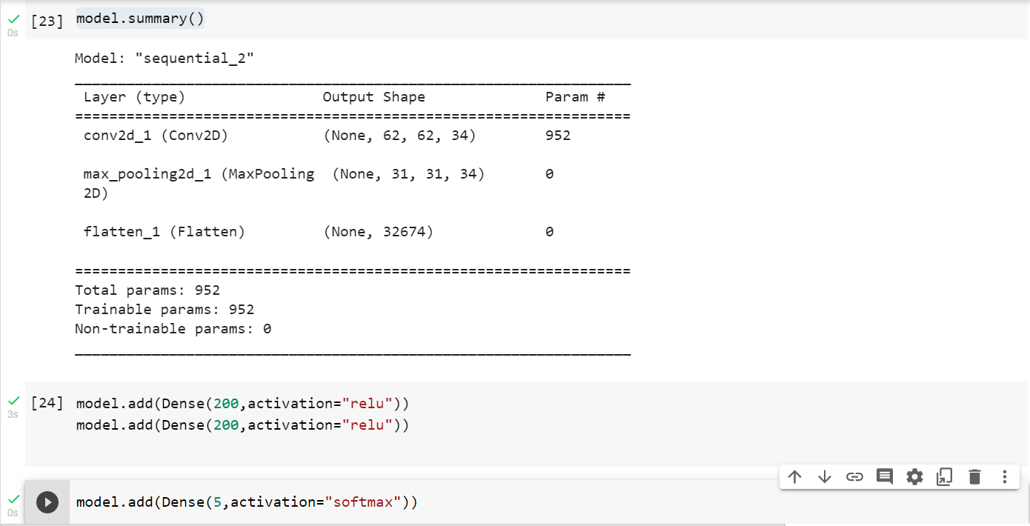

QUESTION 5:

Compile the Model

model.compile(loss="categorical_crossentropy",optimizer="adam",metrics=['accuracy'])



QUESTION 6:

Fit the model

model.fit(x_data, epochs= 5, steps_per_epoch= len(x_data) ,validation_data=0.0,validation_steps=0.0)

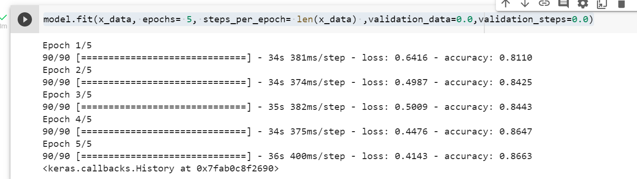

QUESTION 7:

Save the Model

model.save('flowers.h5')



QUESTION 8:

Test the Model

import numpy as np

from tensorflow.keras.models import load_model

from tensorflow.keras.preprocessing import image

img = image.load_img(r"/content/drive/MyDrive/IBM Assignments/flowers/rose/10090824183_d02c613f10_m.jpg")

img

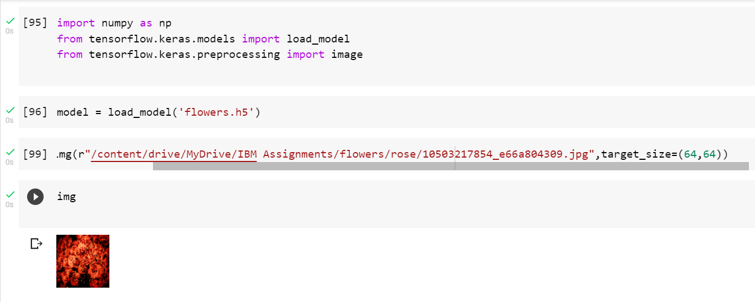

x = image.img_to_array(img)

x

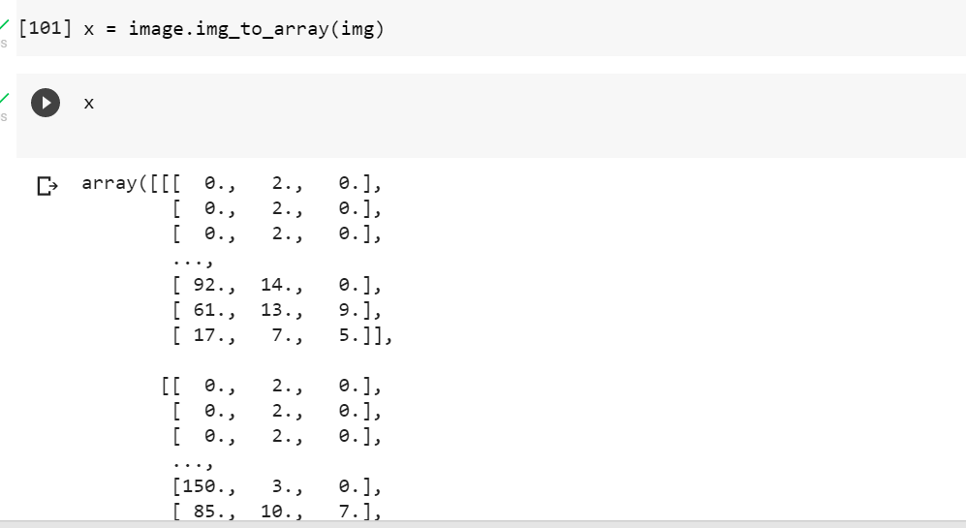

x=np.expand_dims(x,axis=0)

pred= model.predict(x)

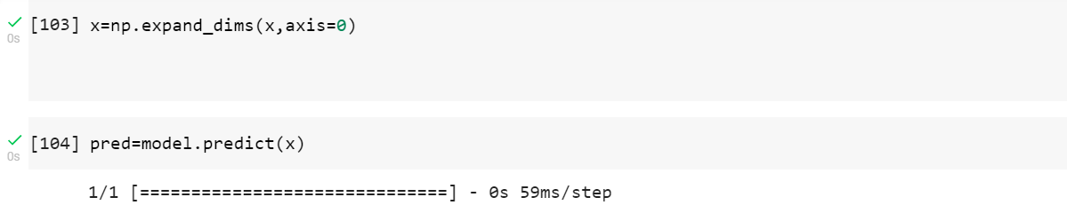

x_data.class_indices

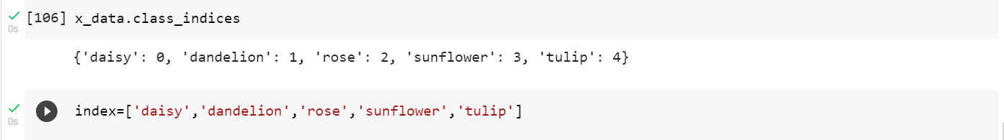

#predicting

